Vintage Marantz Model 9 amplifiers (1 pair), Model 7 preamplifier, and Model 10b tuner for sale in Atlanta. All bought together. Will sell together. Original owner has passed away. All units recently refurbished. Paperwork included. Grado Lab Series turntable also refurbished and included. No speakers. $17,000 for complete package. Email crautenstrauch@yahoo.com

Marantz amplifiers- Model 9- 117V, 60cy, 190-250W (1pair)
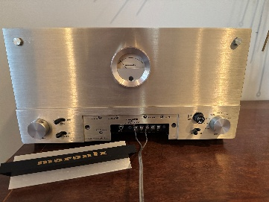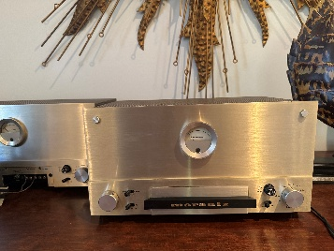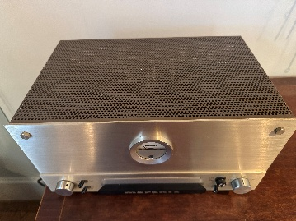
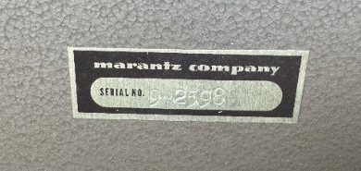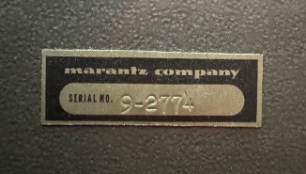

Marantz preamplifier- Model 7- 117V, 50-60cy, 35W
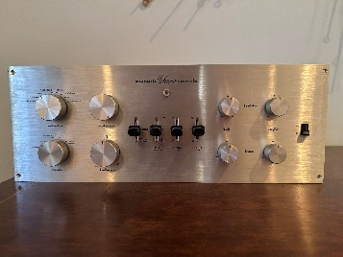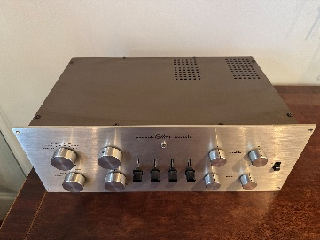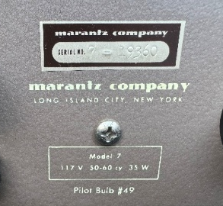

Marantz tuner- Model 10B
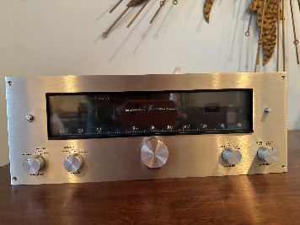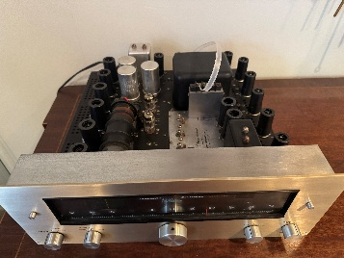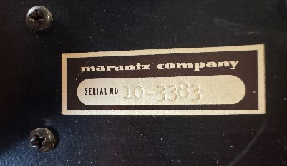

Grado Lab Series turntable
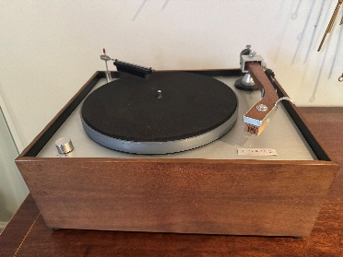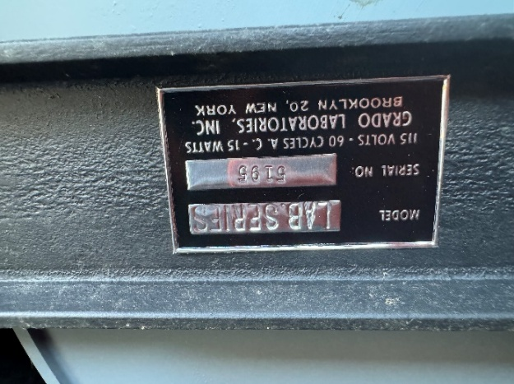

Original Brochures
