Fellow members,
I recently became aware that several, maybe many members are not able to see all of the information on the CRW website at crwoodturner.clubexpress.com or https://crwoodturner.clubexpress.com when logged in, especially on mobile devices. As such, you may not be aware of the missing information. I am making updates, revisions, adding information on a somewhat regular basis in order to provide useful information to you and our guest viewers.
After lots of head scratching, trying out different devices; PC, laptop computers mobile devices, consultation and problem solving, I think I’ve found the reason. Lots of frustration was involved, including from this author and probably the members.
Therefore, to ensure you’re getting the latest information on a mobile device, please look at bottom of your screen for the menu bar. You’ll need to make sure you’re using the Desktop view. If using the mobile device view, you’ll only see partial information, and not always the latest information. I’m not sure why that occurs! Here is a screenshot from my phone.
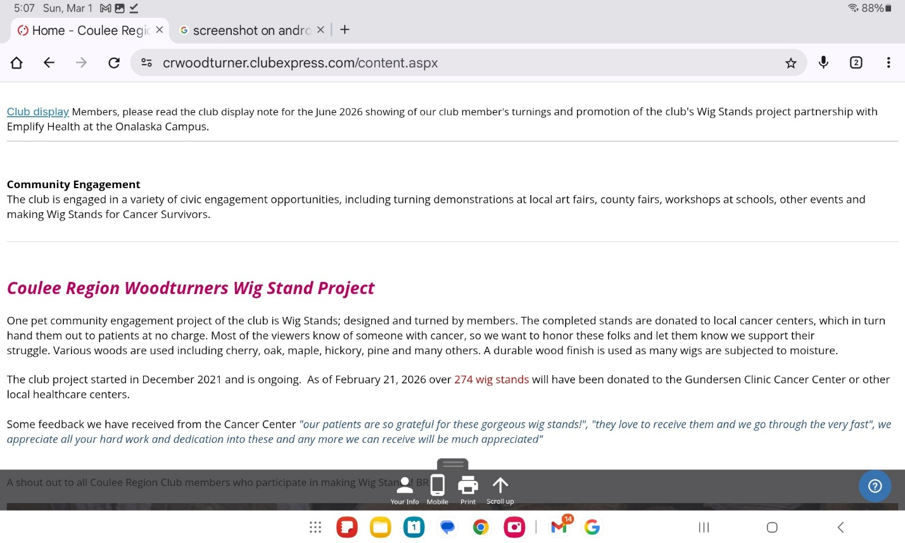

At the bottom Menu: Your info, Mobile, Print, and scroll up. This is really the PC view. If you click on Mobile, you’ll be in mobile view , but a larger screen icon will be visible (which should be a PC).
If you take the club’s web address from FB( facebook), we think the FB browser may interfere with you’re web browser, not sure!
Please send me any questions or feedback so I can address those at the next club meeting as I will be managing the web tour, etc.
Bob Raasch

