Record Returns: 2,150 Salmon Spawned in Putah Creek
WEDNESDAY, DEC 17TH, 2025
Collaborative habitat creation and water management efforts offering prime spawning conditions for salmon in creek that runs from Lake Berryessa to Sacramento River
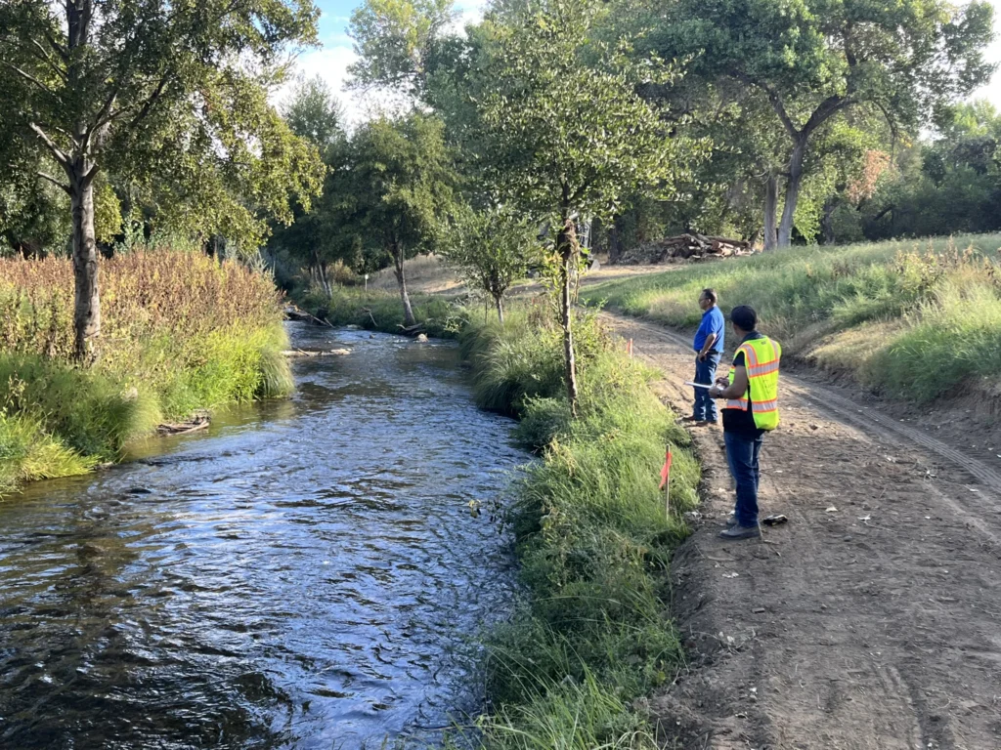Little Putah Creek attracted 2,150 spawning Chinook salmon in 2025, according to a Solano County Water Agency report. (Courtesy of Solano County Water Agency)
Winters, CA – A record 2,150 King Salmon (Chinook salmon) returned to spawn in Putah Creek this fall. Timely water releases, habitat creation and regional collaboration among various public and private organizations are being credited with the successful run.
Putah Creek, which runs along the border of Yolo and Solano Counties near Sacramento has historically supported a small, but vital salmon population. Estimates in 2016 put the salmon return at 1,700, but this year’s record-breaking number is the result of a precise, individual count conducted by biologists with the University of California, Davis at the Department of Wildlife, Fish, and Conservation Biology.
“The number of adult salmon returning in 2025 is a testament to the collaborative efforts among citizens, water managers, landowners, and scientists who are all working together to create a creek that can support people, fish and wildlife,” said Solano County Water Agency General Manager, Chris Lee. “This successful run validates the work done to date and gives us great confidence Putah Creek will continue to support salmon runs for generations to come.”
Key Factors on Putah Creek:
- 25 Years of Investment: The success is the culmination of a 25-year, $20 million grant-funded restoration effort.
  - This includes current work on salmon passage in the lower creek, including the Yolo Bypass Wildlife Area, which is funded by the California Department of Fish and Wildlife and Wildlife Conservation Board.
- Targeted Habitat Enhancement: In 2025, the Solano County Water Agency (SCWA) placed 500 tons of gravel in the creek. Salmon rely on clean gravel beds to build their nests for spawning.
- Adaptive Water Management: SCWA also implemented a test release of extra water this year, timed to mimic natural flows, a technique known as functional flows. This pulse of water appears to have successfully attracted and guided more salmon into the creek.
The strategies implemented at Putah Creek align with the principles of the Healthy Rivers and Landscapes (HRL) program, a statewide effort supported by the Solano County Water Agency and dozens of other signatories across the state that represent 32-million Californians from Redding to San Diego. The HRL program demonstrates the need to integrate habitat modifications, along with functional flows, to improve conditions for salmon during their critical freshwater life cycle stages.
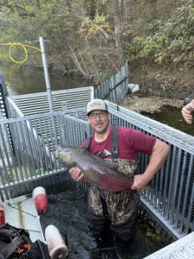SCWA Manager of Water Resources, Drew Gantner, helps UC Davis count the Putah Creek salmon.
A Future for Putah Creek’s Wild Population
With more than 2,150 adults spawning, the creek is expected to produce potentially half a million baby salmon next spring—a level of natural production comparable to a small fish hatchery.
While about 80% of Putah Creek’s returning adults currently originate from the Mokelumne River hatchery, the goal is to significantly increase the number of returning adults that originate from Putah Creek instead. In previous years, about 12% of the returning adults were born directly in Putah Creek. If a greater percentage of the 2025 progeny survive and return as adults, the run could grow even larger, offering a much-needed boost to California’s overall declining salmon populations.
“The future of salmon in California depends on supporting the entire salmon lifecycle; including spawning areas, food production, protection from predators, and availability of water,” said Streamkeeper Max Stevenson. “While much work remains to be done, 2025 is a historic success, marking a pivotal moment in our goals for native Chinook Salmon.”
For more on the Putah Creek success, please contact Max Stevenson, Putah Creek Streamkeeper, mstevenson@scwa2.com, or visit www.scwa2.com.

