Deep South Astronomers Pilgrimage Trip to West Texas in April 2027

For the past several weeks since the end of the Deep South Star Gaze at the Feliciana Retreat Center, Len Philpot (PAS member from Pineville, LA and a long time DSSG and Texas Star Party attendee) and I have been focusing on an astronomy adventure that would give us notably darker skies than what we experience in our part of the south where we have higher humidity, lower elevation and more significant light pollution than other areas further west (basically the west Texas area).

While we can see Milky Way overhead at the Feliciana Retreat Center, as we did at the White Horse Retreat Camp, our rural skies are getting brighter as there are more lights compared to just a few years ago and certainly as compared to when most of us remember when we were growing up. Going back to our first Deep South Star Gaze at Percy Quin State Park in 1983 I believe most attendees who attended during our early years would say that it was clearly darker in the 1980’s. All of our DSSG sites over the years have brightened considerably due to light pollution be it more lights or different types of lighting. The only ways to really fight this problem is thru 1) Legislation, albeit difficult, frustrating and slow, or by 2) physically going to locations that offer darker skies.

As said before, the hallmark of darker skies are three-fold, you need:

1) Lower population density with the accompanying proliferation of lighting for whatever reason

2) Lower humidity - as humidity suspended in the sky mirrors and reflects light

3) Altitude - as with increasing altitude you get above the muck, typically 3000 ft. and above is where you really begin to see the benefit of altitude.

Having thought about all of this and discussing it with others, particularly with Len Philpot, the two of us have been on a quest to find a location where we can go for at least a few days of observing and photographing the night sky where we can indulge under a truly dark nighttime sky. Another requirement is Lodging. Neither of us has an rv, camper or even a tent. We want comfortable lodging!

Our quest had us considering a number of possibilities ranging from areas a bit closer to home including a few locations near Junction, TX or Ft. Griffin, TX or Ft. McKavitt, TX which are all about 650 miles away and a few other areas up to and including the Ft. Davis area where the Texas Star Party is held which is about 950 miles away.

The plan from early on was to do this around the time of New Moon in early April 2027 (new Moon is on Tuesday, April 6th).
To put a darker sky in perspective, we were looking for a site that based upon the improvement in the sky based upon SQM and Bortle scale measures showed an improvement in the darkness of the darker site compared to rural southeast Louisiana and Mississippi equivalent to comparing urban New Orleans and Baton Rouge to a location like the Feliciana Retreat Center. For those of you impressed by the sky overhead at the Feliciana Retreat Center, you will be truly blown away by a truly dark sky like the sky we have been seeking and we know we have found the perfect location.

It is called the 3 Rivers Ranch which is located between the very small communities of Crowell and Paducah, TX. Via Dallas it is a 738 mile/11 hour drive for me. This location is owned and operated by Texas Tech University. Texas Tech, which is in Lubbock, is about 145 miles away, so no light issue from there. Altitude is about 1600 feet above sea level.

3 Rivers Ranch is an observatory complex that caters to anyone wanting to experience an inky black night sky. To supplement what amateur astronomers may with a large dome housing a D&G 15" f/12 refractor and a large roll off roof observatory housing a large, 30 inch dobsonian reflector. It has various housing possibilities including bunk houses and family cabins. RVs, campers and tent camping is also permitted. The prices are reasonable. The observing fields are well kept and not barren desert land.

Here is a video - please look at it now!

Texas Tech University System 3 Rivers Ranch - YouTube

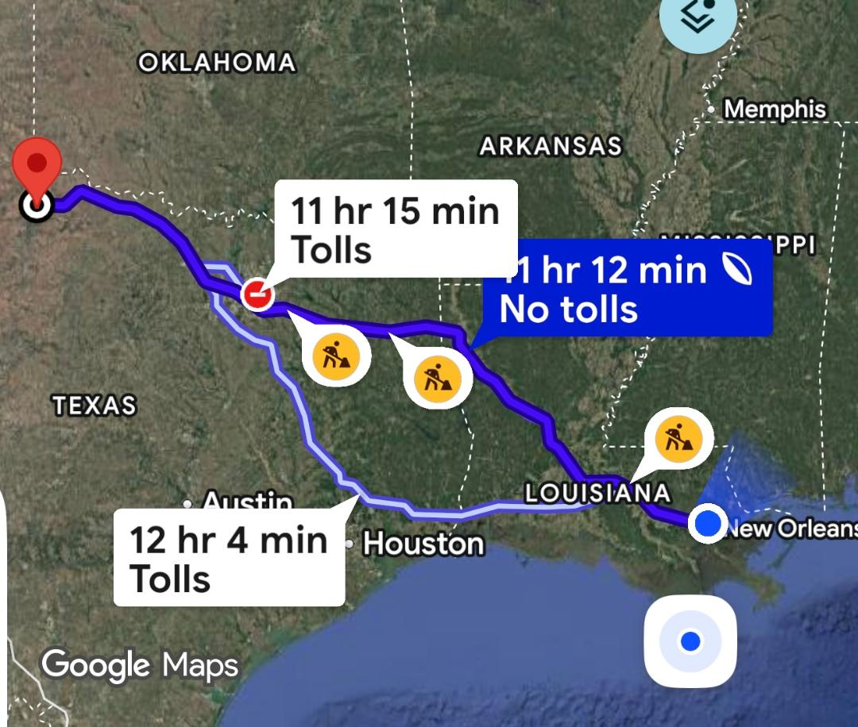
Route from New Orleans to 3 Rivers Ranch

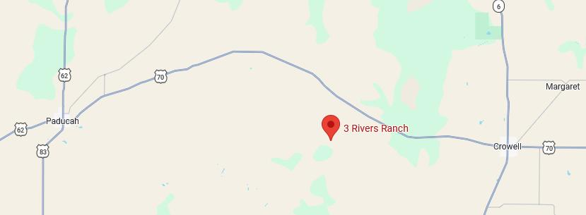
3 Rivers Ranch Location between Crowell and Paducah
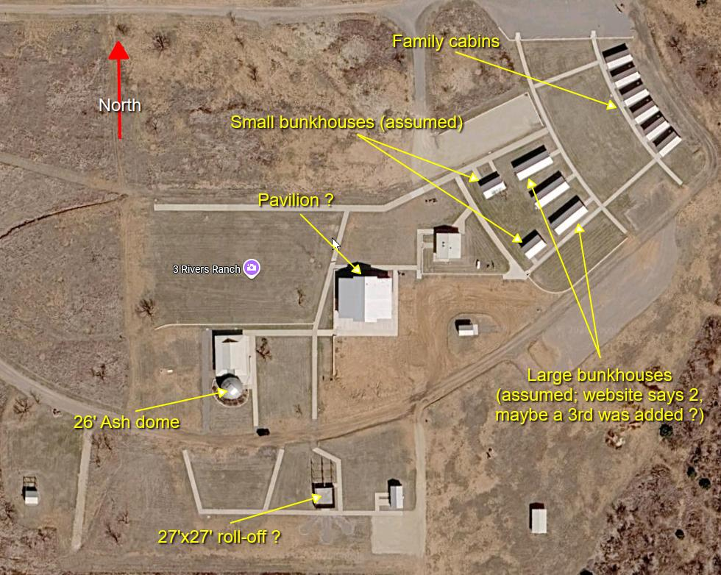
Layout of 3 Rivers Ranch with labels

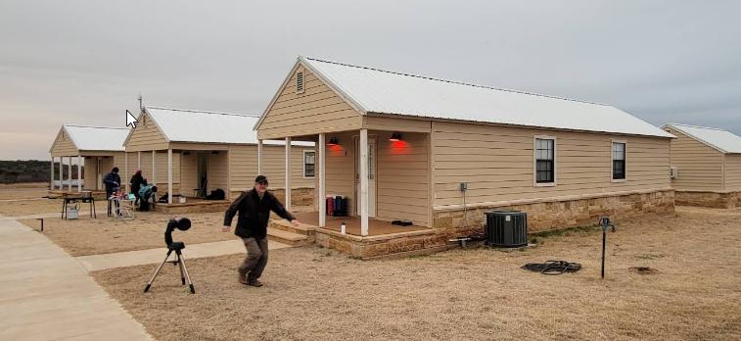
Large Bunkhouses at 3 Rivers Ranch, sleeps 11 in lower bunks
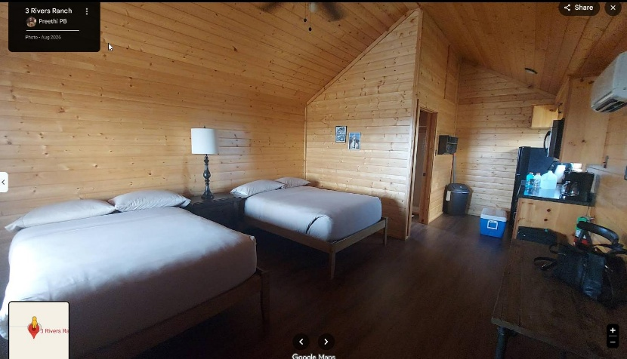
Family cabin with 2 double beds, bathroom and a kitchenette

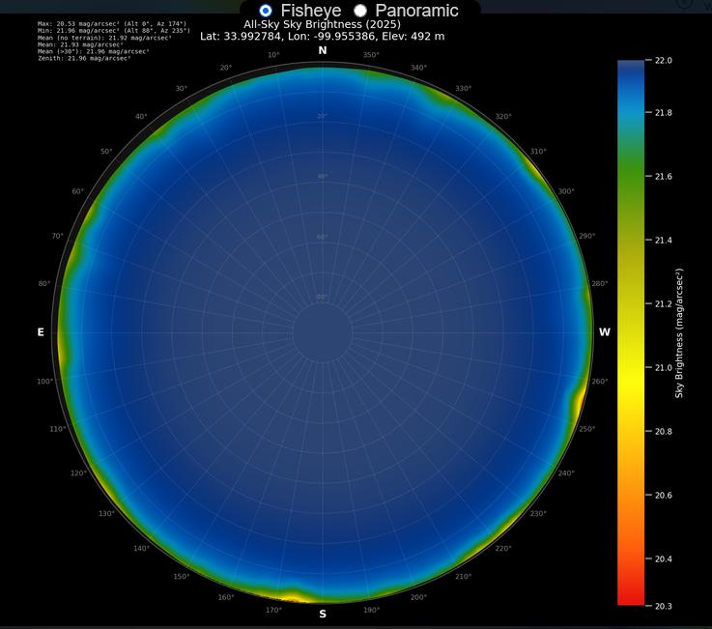
Night Sky Fisheye attesting to the darkness

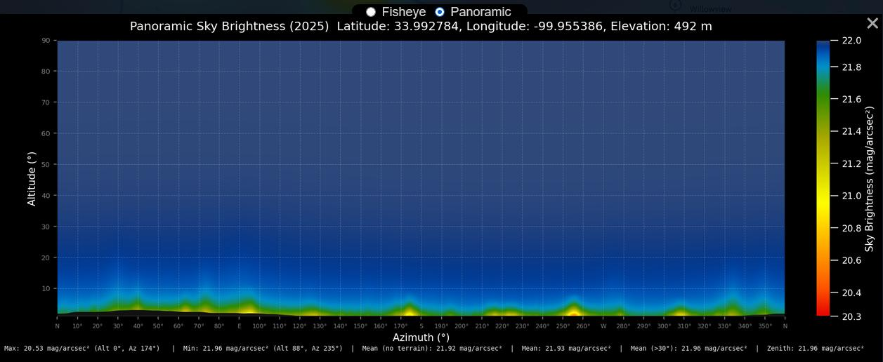
Panoramic Night Sky view

What is weather like at the 3 Rivers Ranch during April?

April is generally one of the nicest months of the year in this area of Texas, especially if you're considering a spring trip, ranch stay, or astronomy outing.

Typical April Weather in Crowell
Weather Factor | Average
Daytime High | 76-77°F (24-25°C)weather-us+1
Nighttime Low | 54°F (12°C)weather-us+1
Rainfall | 0.9-2.5 inches during the month, depending on the climate dataset used weather-us+2
Relative Humidity | About 53% weather-us
Sunshine | About 9 hours of sunshine per day weather-us
Daylight Length | Approximately 13 hours by mid-month weather-us

What It Feels Like

- Mornings are usually cool, often in the 50s°F.
- Afternoons are pleasantly warm, commonly reaching the mid to upper 70s°F.
- Humidity is generally moderate and much lower than East Texas or Louisiana.
- Spring cold fronts occasionally bring windy days and thunderstorms.
- Late freezes are uncommon, the average last frost is typically in March. plantmaps
For Astronomy

Since you've been looking at remote Texas properties for dark-sky observing, April is often excellent around the Crowell area:

- Comfortable nighttime temperatures, usually 50-60°F.
- Lower mosquito pressure than summer.
- The Milky Way core begins returning to the evening sky later in the month.

Clothing Recommendation

Bring:

- Light pants or jeans
- T-shirts and a light jacket
- Windbreaker for frontal passages
- Warm layer for late-night observing sessions

For astronomy, I'd expect a typical midnight temperature around 55°F, which is much more comfortable than summer observing in Texas.

On site
- 26' Ash dome with 15" f/12 D&G refractor on AP 3600; eyepiece carousel with 21 Ethos, 30 Nagler, 44 wide angle
- 27' x 27' roll-off with 30" Obsession w / ServoCat; also houses a 20" Obsession w / push-to DSCs that can be rolled outside
- Conley remote controlled roll-off (various remote gear that don't apply to an on-site visit: Paramount ME, SolarMax 90, SV152, etc.)
- 30' x 30' pad that was to be another roll-off but wasn't completed (presumably could be a set-up area?)
- Solar scope pad that was also never completed
- Volunteer break room, AC / heat, fridge, toaster oven, coffee maker, cabinet, etc.

Relevant rates (as published, I know no more)
- Group General Entry Fee - $100.00 / full day
- Private Use Day Rental - $125 / full day. Campus closed to other guests.
- (2) Small Bunkhouses $125 / night each
  - Sleep 10 people each, in 5 sets of heavy duty, sturdy bunkbeds. Heated and cooled.
- (6) Family Cabins $150 / night each ($125 / night for 2 nights or more)
  - Sleep 4 each in two full sized beds. Kitchenette with fridge/freezer, sink, microwave, coffee maker, dinette and private 3-piece bath. All linens included. Heated and cooled.
  - For 4 people this is a no-brainer over the bunkhouse, same price.

Questions / thoughts
- We'd be on our own for meals, but that's gonna be true at many if not most of the other places we'll find.
- Depending on how many would go, could this be viable price-wise?
- Can the facility / lodging be rented without use of the telescopes (i.e., bring our own)? Or are the scopes part of the deal?
- If the actual daily cost if $100 (group fee) + $125 (family cabin) for 4 people, that's $56.25 a day -- A steal!!

Questions sent to the 3 River Ranch and Texas Tech by Len Philpot and the reply in red.

- Are there bathroom facilities in each of the bunkhouses or is there a separate bathhouse? Bunkhouses do not have restroom facilities. A building with restrooms/shower rooms is adjacent about 50-100 feet away depending on which bunkhouses are rented.
- Are any family cabins available with four single beds (I saw a photo with dual double beds)? Are double beds the only option? We're a bunch of (grumpy old) guys and well, you know... 🙂 All cabins are identical with 2 full-size beds.
- Are there kitchen(ette) type facilities available other than in the family cabins? The pavilion has a catering kitchen which can be rented. It has a residential stove/oven, residential size refrigerator/freezer, microwave and 2 compartment sink, as well as ample counter space for cooking devices (not provided). This space can be rented alone for $50/day or with the pavilion (tables and chairs for 96) for $300/day.
The dining hall classroom has tables and chairs for 36 along with a residential refrigerator/freezer, microwave and coffee pot. It has space for meal service or use of roasters, crock pots, etc (not provided) You are also welcome to cook outside on anything gas or electric.
- Is power for telescopes / mounts available outside? Yes, each cabin porch has power and there are outlets situated around most all sidewalks and buildings. Extension cords are encouraged.
- Is outdoor lighting controlled / limited to preserve dark-adaptation? Yes, all outdoor lighting is red. Red solar pathway lights can be turned off during your visit if you prefer.
- Does Crowell have any retail resources for ice, groceries, restaurants, etc.? If not, what's closest? Crowell has an Allsups convenience store which sells ice, some grocery staples, hot box foods and beer but we no longer have a grocery store,. The nearest grocery would be in Vernon Texas (45 miles) along your route of travel, or Quanah Texas (37 miles) if you need to make a quick run for something forgotten. Vernon has a Walmart, United Supermarket and hardware stores as well as chain and local restaurants. Quanah has a smaller United Supermarket and limited other options. Crowell has a diner that is open M-F, 6-2 and a pizza place that is open Thursday and Friday evenings, and Sat-Sun for lunch and dinner. Paducah, TX. (25 miles west) has a 2-3 other dining options.
- Is there any kind of on-site meal service? If not is there a business that can cater if we have a large enough group? No meal service, but I can provide some catering contacts.
- Schedule-wise we don't require a weekend. We're pretty much all retired so weekdays are good.
Is April 5 (arrival) through April 8 or 9 (departure) available? If not,what's nearest to that those dates? Depending on your accommodations needs, I might be able to do check in on Monday, 4/5 but I am the only staff member so any turnover after the Star Party is done by me personally, and that can be time consuming.
- How soon would payment be required? Can we reserve before payment is made? Reservations can be made at any time. I prefer to hold off on payment until you arrive just in case of inclement weather or other cancellations/changes.
- Does payment for a group need to be combined or can each attendee pay individually? I realize the lodging, entry fee, etc. are for the group. Payment can be made individually; we would need to decide who pays for common areas and private reservation fees (if you opt for those).
- Is there a minimum attendee count for exclusive use or is it just a matter of paying the private fee? The only minimum participation is set on the guided telescope viewing. That minimum is 10 guests. Any group can pay the rate for private rental to have exclusive access to the property.

Cady Alvarado, Assistant Director Texas Tech University System

Here is more info, perhaps clarifies a thing or two –
This is the site with all the info: https://www.texastech.edu/3-rivers-ranch/astronomy-campus-at-3rr.php

The "Book your stay" menu choice shows prices.

For reference, here's a copy / paste of the whole schmeer....

Day Use Entry Fee $8.00 per person
  - Birding, hiking, horseback riding, mountain biking
  - No motorized vehicles on trails. Personal horses only. Liability Release required.
Group General Entry Fee $50.00/half day & $100.00/full day
Private Use Day Rental $75.00/half day & $125/full day. Campus closed to other guests.
Tent Camping $10.00 per person per night
  - Primitive, no campfires, no utilities. Restrooms and showers available.
RV Space $20/night (electricity only) $30.00/night (water & electricity)
  - Top (5) sites are 30/50 amp electric only.
  - Bottom (6) sites are water and 30/50 amp electric.
Dining Hall/Classroom $75/half day & $125/full day for reserved use
  - Seating for 36 guests with full size refrigerator/freezer, microwave, coffee maker and serving area. White board.
Dome Classroom $125/half day & $200/full day for reserved use
  - Seating & tables for 24 guests with white board, projector and drop-down screen.
Pavilion $175/half day & $250/full day for reserved use. $50 additional fee for catering kitchen.
  - Seating and tables for 96 guests indoors or outdoors.
  - Optional catering kitchen with refrigerator, range, sink and serving counters/windows.
(2) Small Bunkhouses $125/night each
  - Sleep 10 people each, in 5 sets of heavy duty, sturdy bunkbeds. Heated and cooled.
(2) Large Bunkhouses $150/night each
  - Sleep 22 each in 11 sets of heavy duty, sturdy bunkbeds. Heated and cooled.
(6) Family Cabins $150/night each ($125/night for 2 nights or more)
  - Sleep 4 each in two full sized beds. Kitchenette with fridge/freezer, sink, microwave, coffee maker, dinette and private 3-piece bath. All linens included. Heated and cooled.
  - CANCELATION POLICY – Reservations canceled within 24 hours of the start of your event will incur a $50.00 late cancelation fee.
Guided Telescope Viewing $100, minimum participation required. By reservation only.

Note – we have more information about day trips to either Palo Duro Canyon State Park or to Caprock Canyon State Park, here are some video links for those –

Palo Duro Canyon State Park, Texas

184 miles to the Visitor Center (2 hours 52 minutes)

Caprock Canyons State Park: The WILDEST Side of Texas! - YouTube

100 miles to the Visitor Center (1 hour 37 minutes)

Information gathered and compiled by Len Philpot and Barry Simon

