Celebrity Spain, Morocco and Portugal Cruise Oct 7-16, 2027
Number of guests: 2 Guests per cabin
*Taxes & fees included

Inside
$1,912 USD/person*
$3824 Total/Cabin
Veranda
$2376/person*
$4752 /Cabin
Concierge
$2724 USD/person*
$5448 Total/Cabin

Deposit: $450/person Classic drink package and Wi-Fi included
Group flights will be available in mid-November
Assigned Vacation Planner: Cecilia San Juan
Group booking number: 7839063
Hours: Monday - Saturday 9:00 AM – 6:00 PM EST
Telephone: 888-727-4907
Extension: 42366
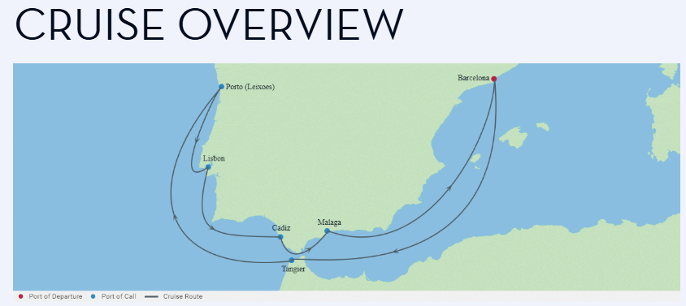

Day 1 Thu, Oct 7 Barcelona, Spain Departs at 5:00 pm
Formerly a sleepy Spanish city, Barcelona has recently been reborn as an eclectic fusion of the modern and medieval. This coastal city exudes European charm and welcomes multitudes of travelers every year. It’s a major destination with must-see architectural gems that date back some 2,000 years. You’ll encounter fascinating examples from the Roman Empire, the Middle Ages, the Modern masters like Gaudî, and many Cataluñian greats. Round out your cruise to Barcelona dining at a tapas bar and savor a variety of delicious small dishes to share—from traditional Spanish to the more innovative.
Your ship departs promptly at 5:00 pm, so we recommend arriving at least 2-3 hours early to smoothly navigate check-in and boarding. All ship amenities are open and ready, so kickstart your vacation with a refreshing drink or a delicious snack.

Day 2 Fri, Oct 8 Day at Sea Celebrity Equinox

While at sea, indulge in some well-deserved relaxation before your next adventure. Unwind by the pool, pamper yourself at the spa, savor exquisite cuisine, or discover the unique venues on board. Your next incredible destination awaits.

Day 3 Sat, Oct 9 Tangier, Morocco Docked from 7:00 am - 6:00 pm

From tea and spice markets to Moroccan haute cuisine, caves, museums, and preserved fortresses from centuries past, Tangiers has a great deal to offer. This majestic city is known as “The Door of Africa”, and the beating heart connecting two worlds.

Day 4 Sun, Oct 10 Day at Sea Celebrity Equinox

Day 5 Mon, Oct 11 Porto (Leixoes) Docked from 8:00 am - 6:00 pm

Porto, Portugal’s second largest city after Lisbon, is one of Europe’s oldest cities and was registered as a World Heritage Site by UNESCO in 1996. Of course, Porto’s name itself hints at perhaps Portugal’s most famous export—port. This is where the fortified wine was first produced.

Day 6 Tue, Oct 12 Lisbon, Portugal Docked from 7:00 am - 5:00 pm

Lisbon, Portugal- See why this city stands out above all others as you stroll along elaborate mosaic sidewalks and pass by the Monument to the Discoveries. A quick trolley ride transports you to the cobblestone district of Baixa. Or be lured away and pampered in the resort cities of Cascais and Estoril.
Take a wonderful tour through Lisbon and you’ll discover Graca, the beautifully restored old area of the city, filled with old tiled buildings and mansions and Chiado, Lisbon’s arts district, for a different air of sophistication with its many boutiques, galleries and theaters.

Day 7 Wed, Oct 13 Seville (Cadiz), Spain Docked from 11:00 am - 8:00 pm

From Cádiz you can easily get to Seville, exploring the old town with its quaint Moorish feel as well as its impressive monuments, pretty parks and lovely architecture. Along the way, restore your energy at any of the mouth-watering tapas bars offering some of the country’s finest seafood and typical Andalusian cuisine.

Day 8 Thu, Oct 14 Malaga, Spain Docked from 8:00 am - 6:00 pm

Malaga is the gateway to the Andalusian countryside and the Costa del Sol, some of the region's most impressive beaches. It also is home to a number of magnificent palaces, including the Moorish Alcabaza and Gibralfaro.

Day 9 Fri, Oct 15 Day at Sea Celebrity Equinox

While at sea, indulge in some well-deserved relaxation before your next adventure. Unwind by the pool, pamper yourself at the spa, savor exquisite cuisine, or discover the unique venues on board. Your next incredible destination awaits.
Day 10 Sat, Oct 16 Barcelona, Spain

Celebrity Equinox
Celebrity Equinox® takes the greatest hits of our Solstice® Series and adds some incredible new experiences to the mix. At The Retreat®, we’ve elevated the suite life to new heights with a sundeck and lounge that make you feel like you have the ship to yourself, along with private dining in our suites-only restaurant, Luminae. Enjoy your own private views anytime in our spacious veranda staterooms. Add in the thoughtful details of our Concierge Class staterooms. Plus, Starlink high-speed internet lets you stay connected even while you disconnect.
We want you fully recharged so you can take advantage of all there is to do on board. Try some of our most popular restaurants, like Tuscan Grille and Murano. Explore an extensive collection of craft beer and comfort food done right at Craft Social. Watch our flair bartenders defy gravity at the Martini Bar. Kick back by the pool or cozy up with a good book at The Lawn Club. Dance like no one’s watching at our Silent Disco. On Celebrity Equinox, you’ll find yourself wishing there were more hours in the day.
Inaugural date Aug 8, 2009 Refurbish coming in 2027
Occupancy 2852

