**2006 Selene Archer 40 Ocean Trawler**

**SLAINTE** is a 2006 Selene Archer 40 Ocean Trawler currently available for sale at Skyline Marina in Anacortes Washington. The boat is being offered for sale by the original owners at $510,000.

SPECIFICATIONS:

Price: $510,000

Boat name: SLAINTE

Make: Selene

Model: Archer 40 Ocean Trawler

Year: 2006

Condition: Excellent/Meticulously maintained: see Latitude Maritime,INC

Category: Trawlers

Construction: Fiberglass

Length (LOA): 45’2”

Beam: 14ft 6 in

Max Draft: 5ft 2 in

Fuel Capacity: 600 usg

Fuel Type: Diesel

Fresh Water Capacity (Gallons): 220 usg

Number of Engines: 1

Engine Make: John Deere

Engine Model: 6068

Engine Power: 267 HP

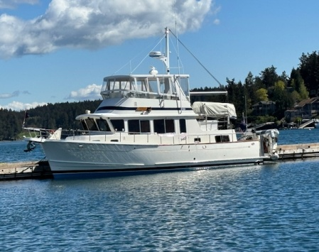

Special features include:

1) John Deere 6068 w/ 2700 hours

2) Bow and stern thrusters SIDE POWER

3) Northern lights 8KW generator w/ 715 hours

4) Bridge: Custom-engineered hardtop, w/polycarbonate (lexan) and vinyl (Isinglass) windows, full enclosure and overhead lights

5) Custom galley modifications w/ microwave

6) AC/DC deep freezer on upper deck

7) SeaWise 12v power dinghy davit system

8) Novurania tender with 30 hp engine

9) Fuel polishing system

10) Hurricane H2 hydronic heater w/3 zone control

11) FullRiver L16 AGM 6vDC house batteries in good condition

12) 2 Tecma marine toilets w Domenic tank watch

13) 2 kayaks and custom stainless steel rack

14) Stainless steel window frames

15) 316L Stainless Steel custom keel shoe rudder support

16) Lofrans windlass & Anchor control w chain counter

17) 400 ft chain, 5/16 High Tensile strength

18) water maker as is

19) upper and lower helm displays with

2 FURUNO radar systems,

2 FURUNO NAVnet GPS systems,

2 displays FURUNO depth sounder,

2 displays GARMIN depth & speed indicator,

1 FURUNO auto pilot w/dual controls,

2 FURUNO VHF radios.

20) Separate GPS on laptop pc. And Hand held VHF radio.